LADYWELL MEDICAL CENTRE EAST
www.ladywelleast.co.uk
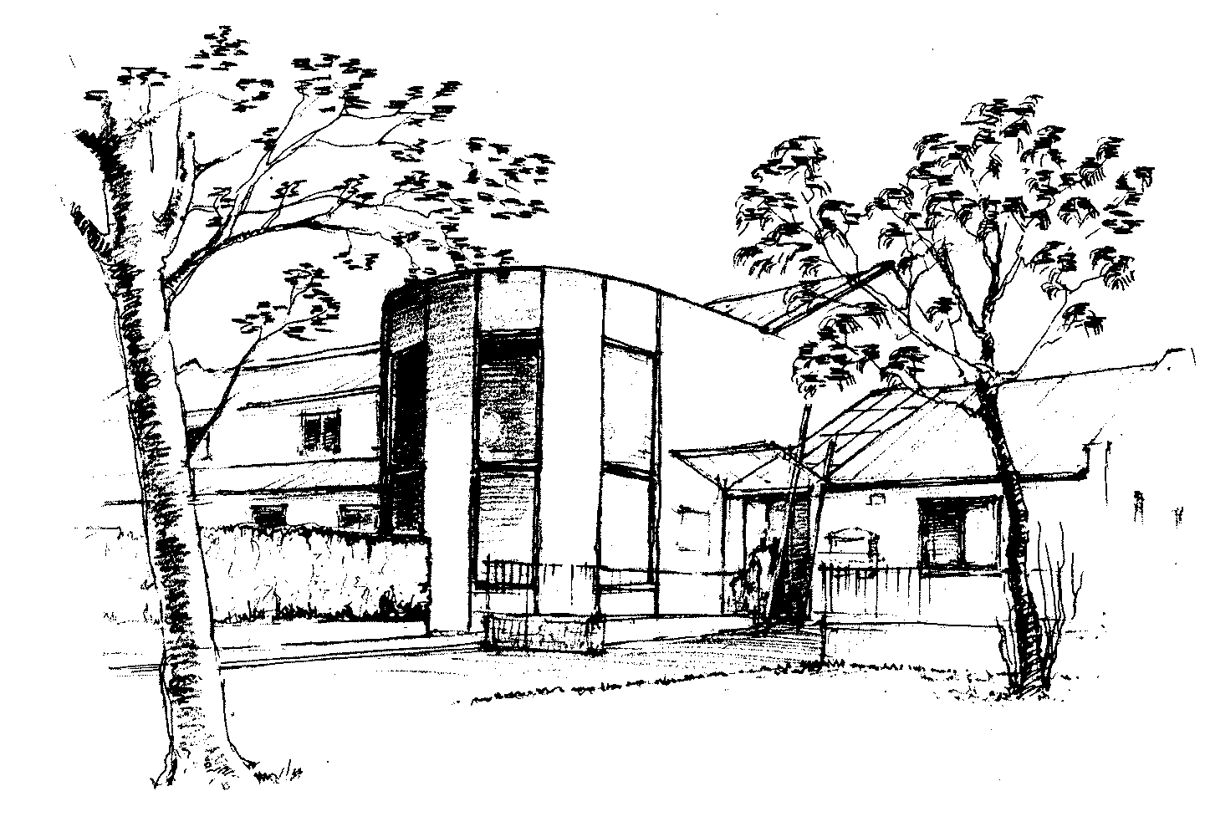
Partners: Partners:
Dr Jane Moore Dr Kirsten Russell Dr Alice Travers Dr Susannah Scott
Dr Nairn McLeod Dr Joanne Brown

SUBJECT ACCESS REQUEST FORM (SAR)

Date of Request ………………………………………..

Initial Request Received by:…………………………….Processed in Reception by………………………

How Received (eg verbal, letter, email etc) ………………………………………………………………...

SAR Request for (Patient’s name) …………………………………………………………… Please Print

Date of Birth……………………………………………………………………………………………..…..

Contact telephone number……………………………………………………………………………………

Requestor’s name (if not patient)…………………….………………………………………… Please Print

and relationship to patient……………………………………………………………………………………

~~~~~~~~~~~~~~~~~~~~~~~~~~~~~~~~~~~~~~~~~~~~~~~~~~~~~~~~~~~~~~~~~~~~~~~~~~~~~~~~

CONSENT

I hereby request Ladywell Medical Centre East release the undernoted records to me
(Please give full information as to what required eg full copy notes, last 5 years notes, letters relevant to specific issue etc). I am aware the Practice has one month to provide requested records.

………………………………………………………………………………………………………..

………………………………………………………………………………………………………..

Patient name (please print)……………………………………………………DoB………………....

Signed: Date:

Signed by Patient [ ] Yes [ ] No

Verbal request or no consent obtained: Signed by staff member: ………………………………………..
~~~~~~~~~~~~~~~~~~~~~~~~~~~~~~~~~~~~~~~~~~~~~~~~~~~~~~~~~~~~~~~~~~~~~~~~~~~~~~~~~~~~

OFFICE USE ONLY

Type of Record Requested:

SAR Accepted [ ] Yes [ ] No

Date Completed: By: Checked By (GP):

Date Patient / Requestor advised (ready to collect):

