Joint Injection Information Leaflet
You have been given this leaflet as your doctor thinks you may be suitable for a steroid injection.
Injections are performed at the surgery by Dr Brown and Dr Moore. The following injections may be offered if deemed appropriate: shoulder, knee or bursa (fatty pad). Any other joints will require referral to a specialist.
Why have you been offered a steroid injection?
Steroid injections can prove beneficial in patients who have problems with pain or stiffness in their joints or surrounding soft tissue. These conditions can include osteoarthritis (degenerative joints) or other soft tissue conditions e.g “frozen” shoulder or tendonitis. Your health practitioner has assessed you as having a one of these conditions and therefore a steroid injection may help your symptoms.
What does it involve?
You will be asked to expose the affected area so wearing shorts or a vest top may be helpful. The doctor will perform a brief examination before marking the area where they will inject. The injection contains steroid and also some anaesthetic (numbing agent) and will be injected using a needle no bigger than that used for a blood test. Following the injection, you may be asked to wait in the waiting room for a few minutes to ensure you feel well.
What happens afterwards?
For the best effect, you should relatively rest the affected area for 5-7 days. This translates as no heavy lifting or strenuous exercise – sedentary activity, driving and low-intensity work is generally acceptable. You may find as the anaesthetic wears off that the area feels more painful than before. This is known as a “post-steroid flare” and should settle within a day or two.
Will it definitely work?
There is a varied response to steroid injections – some people have no benefit, others have some benefit for a few weeks, a minority of patients find a great benefit and an even smaller minority of patients may feel their symptoms are worse.
The injection would be deemed “successful” if you have a good response for 6 weeks or longer. It is possible to repeat the injection but they are not performed more frequently than every 3 months. Repeated injections would be at the discretion of the doctor based on their clinical judgement.
Joint injections often work best if used in combination with physiotherapy or home strengthening exercises. NHS Inform and Versus Arthritis are two very helpful websites that guide you through exercises at home.

What are the side effects?
As with any injection that penetrates the skin, there is a risk of infection. The risk of this is very small. The signs of infection would include redness, swelling or warmth of the area and you should seek immediate medical advice if you notice any of these features.
There are very rare occasions where patients may be allergic to the steroid or the anaesthetic used in the injection. This reaction would usually happen very quickly afterwards which is why we often ask patients to wait in the waiting room for a short time after the procedure.
If you are diabetic then the steroid in the injection may cause your sugars to be slightly higher than normal for a few days. Your doctor will discuss this with you.
If you are on blood thinning medications then it is generally okay for you to have an injection though there is a very small risk of some bleeding into the joint. For this reason we do not perform injections if your INR is high (this is only relevant for patients on warfarin).
What do I do if I wish to proceed?
We run a joint injection clinic on a weekly basis. Your health practitioner can refer you to this if they think you are eligible. Please be aware that you may have to wait a few weeks before an appointment may be available.
Please also complete the below consent form and bring it with you to your appointment. If you have any further questions, please discuss these at your appointment.
I understand the content of this information leaflet and I am happy to proceed with a steroid injection.

Name.................................................... D.O.B.....................
Signed .................................................. Date ........................
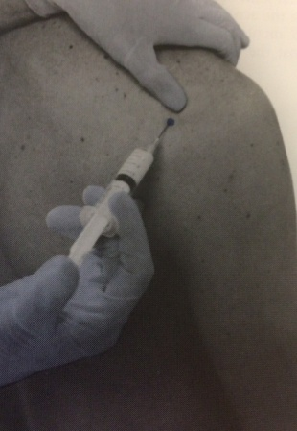
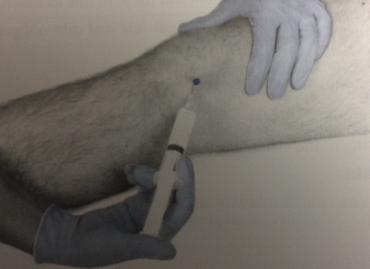

Figure 1: Shoulder injection
Figure 2: Knee injection

